What is Map Reduce?

MapReduce is a programming model that enables large volumes of data to be processed and generated by dividing work into independent tasks and executing the tasks in parallel across a cluster of machines. At a high level, every MapReduce program transforms a list of input data elements into a list of output data elements twice, once in the map phase and once in the reduce phase.
Map reduce outputs the data in the form of key value pairs.
Let’s have a look at map reduce with an example where given a file containing multiple words we need to find out the count of words made from the same characters.
Ex: abc, cba, aaa, aaa, bcd, cbd
Here abc:2,aaa:2, bcd:2
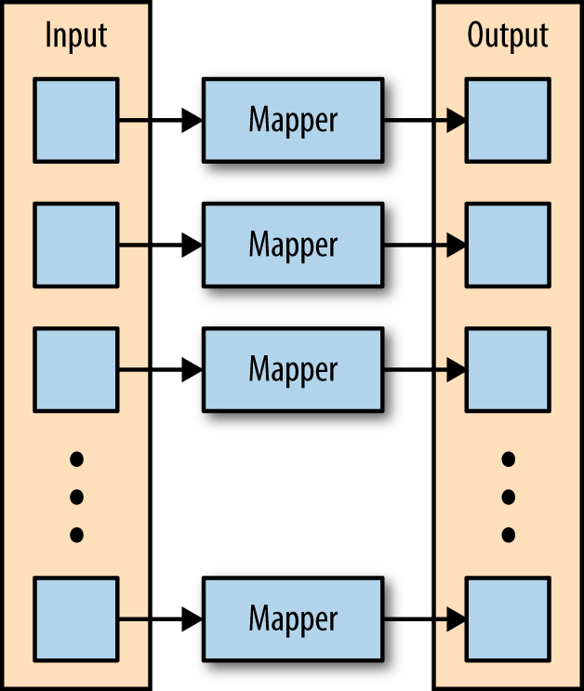

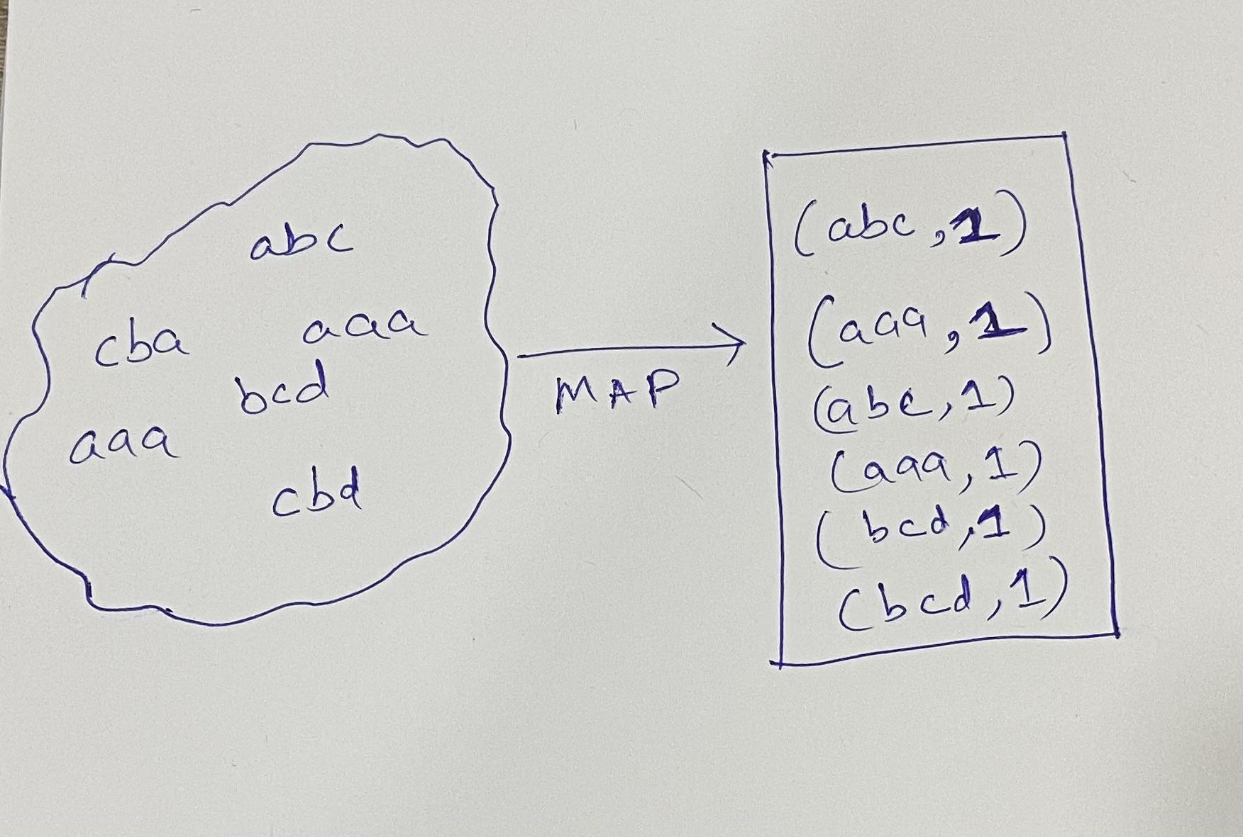
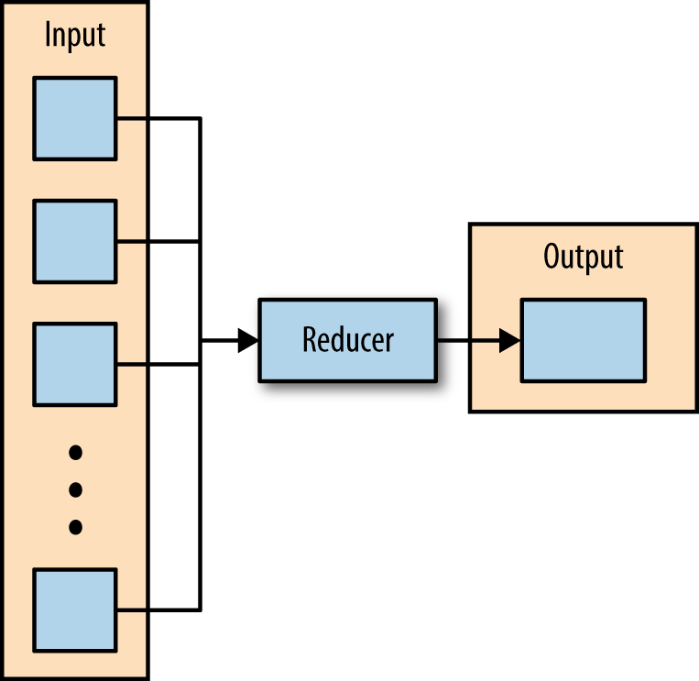
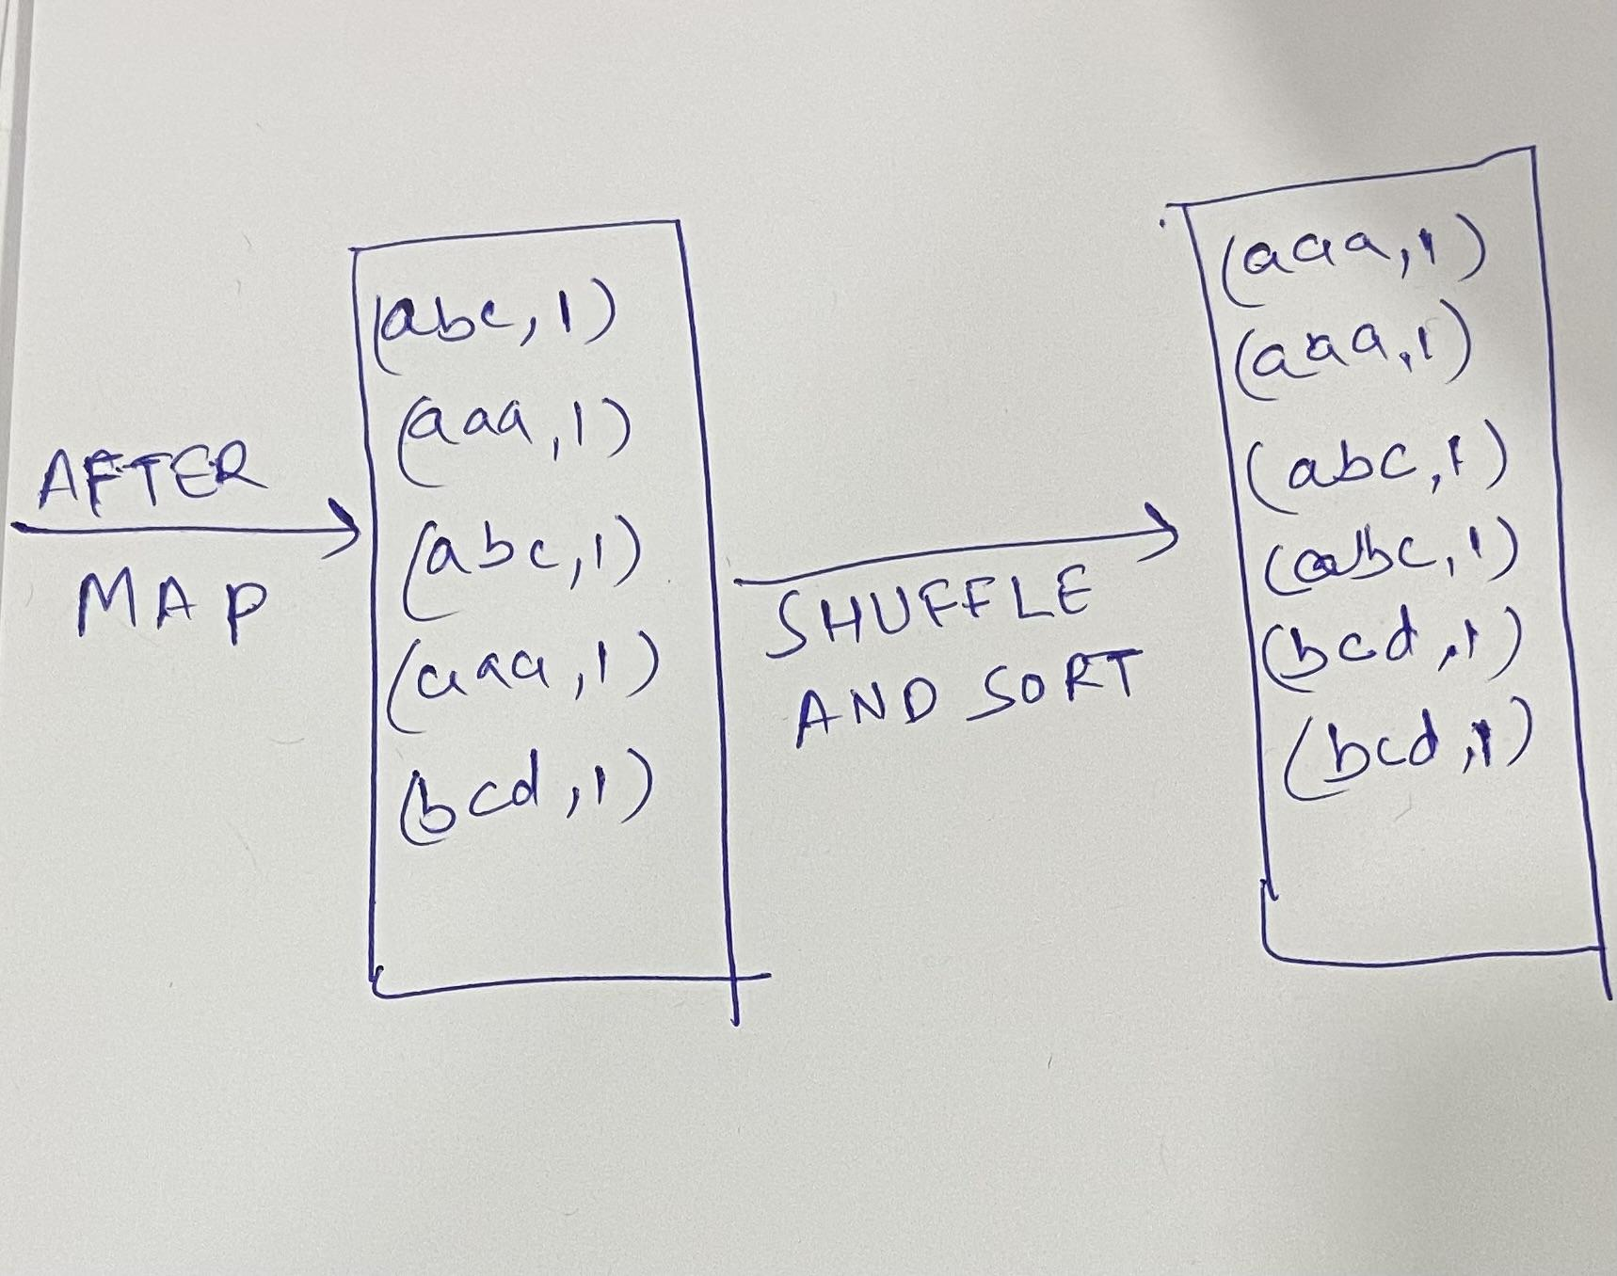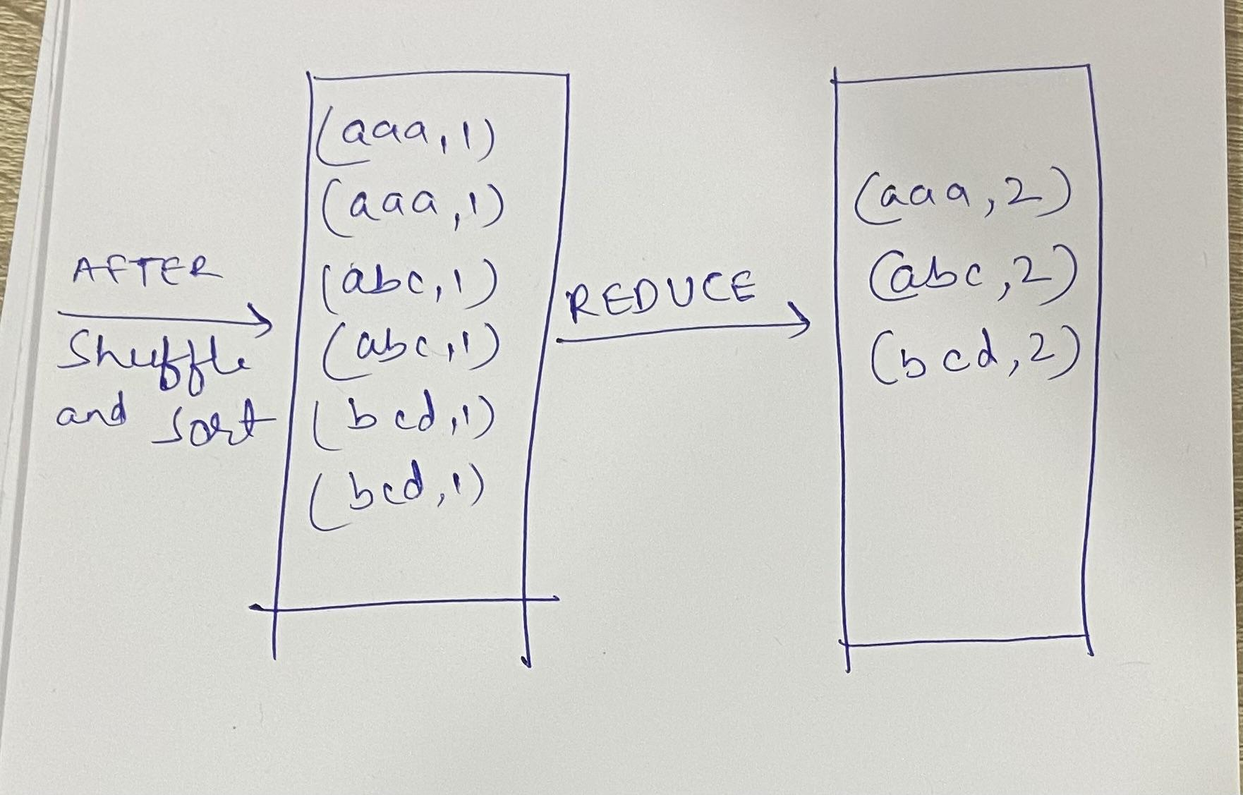

How does Data Flow in Map Reduce
1 Map
2 Combine
3 Shuffle and Sort
4 Reduce

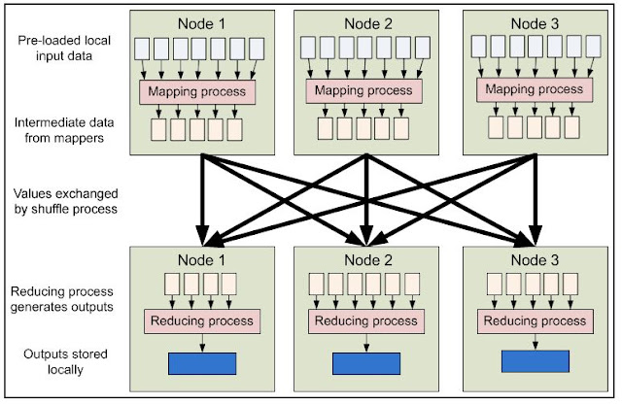
- MapReduce inputs typically come from input files loaded onto our processing cluster in HDFS. These files are evenly distributed across all the nodes.
- Running a MapReduce program involves running these mapping tasks across all the nodes in our cluster.
- Each mapper loads the set of files local to that machine and processes them.
- Combiner is an optional Mini-reducer which performs local aggregation on the mapper’s output. It minimizes the data transfer between mapper and reducer. So, when the combiner functionality completes, the framework passes the output to the partitioner for further processing.

- When the mapping phase is completed. the intermediate (key,value) pairs must be exchanged between machines to send all values with the same key to a single reducer
- Individual map task do no exchange information with one another, nor they are aware of one another's existence
- The user never explicitly marshals information from one machine to another; all data transfer is handled by the Hadoop MapReduce platform itself, guided implicitly by the different keys associated with values. This is a fundamental element of Hadoop MapReduce's reliability.

Let’s understand the data flow in map reduce with a word count example where we are given a 1 Tb dataset which contains multiple words we need to find out the number of occurrences of word in a file

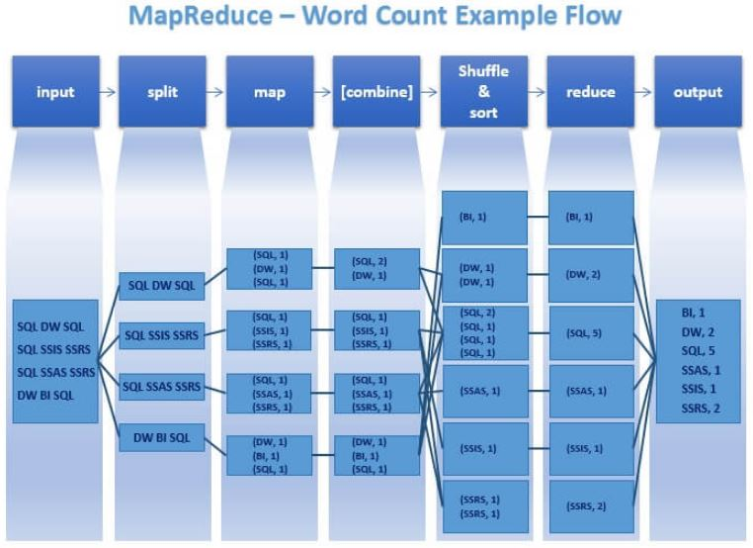

Map Task Execution Timeline

Let’s now focus on a single Map Task. This is the Map Task execution timeline:

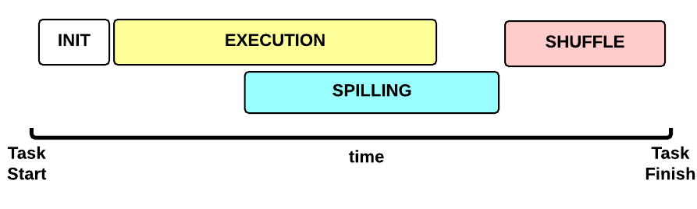
- INIT phase: we setup the Map Task
- EXECUTION phase: for each (key, value) tuple inside the map split we run the map() function
- SPILLING phase: the map output is stored in an in-memory buffer; when this buffer is almost full then we start (in parallel) the spilling phase in order to remove data from it
- SHUFFLE phase: at the end of the spilling phase, we merge all the map outputs and package them for the reduce phase

MapTask: SPILLING
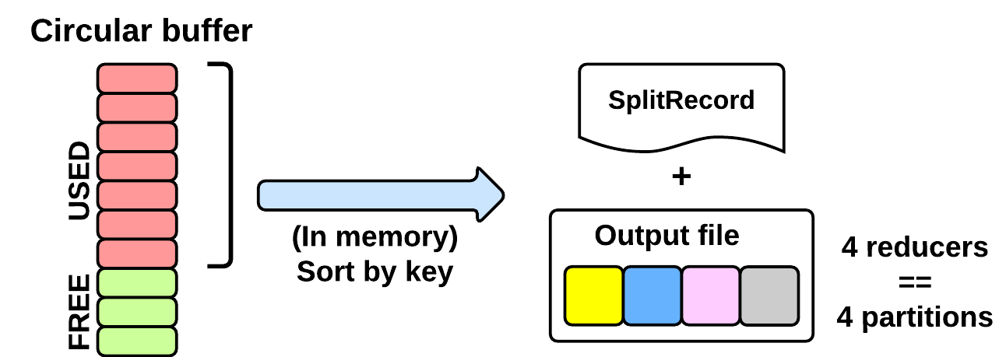
Map writes its output into a circular in-memory buffer (MapTask.MapOutputBuffer). The size of this buffer is fixed and determined by the configuration parameter mapreduce.task.io.sort.mb(default: 100MB).
Whenever this circular buffer is almost full (mapreduce.map. sort.spill.percent: 80% by default), the SPILLING phase is performed (in parallel using a separate thread). Notice that if the spilling thread is too slow and the buffer is 100% full, then the map() cannot be executed and thus it has to wait.
The SPILLING thread performs the following actions:
- it creates a SpillRecord and FSOutputStream (local filesystem)
- in-memory sorts the used chunk of the buffer: the output tuples are sorted by (partitionIdx, key) using a quicksort algorithm.
- the sorted output is split into partitions: one partition for each ReduceTask of the job (see later).
- Partitions are sequentially written into the local file.

Design Patterns
1. Summarization pattern
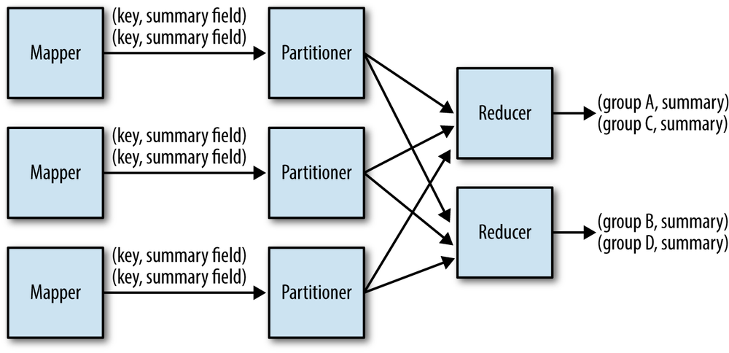

Example: Wordcount, minmax and average etc

2. Filtering Patterns
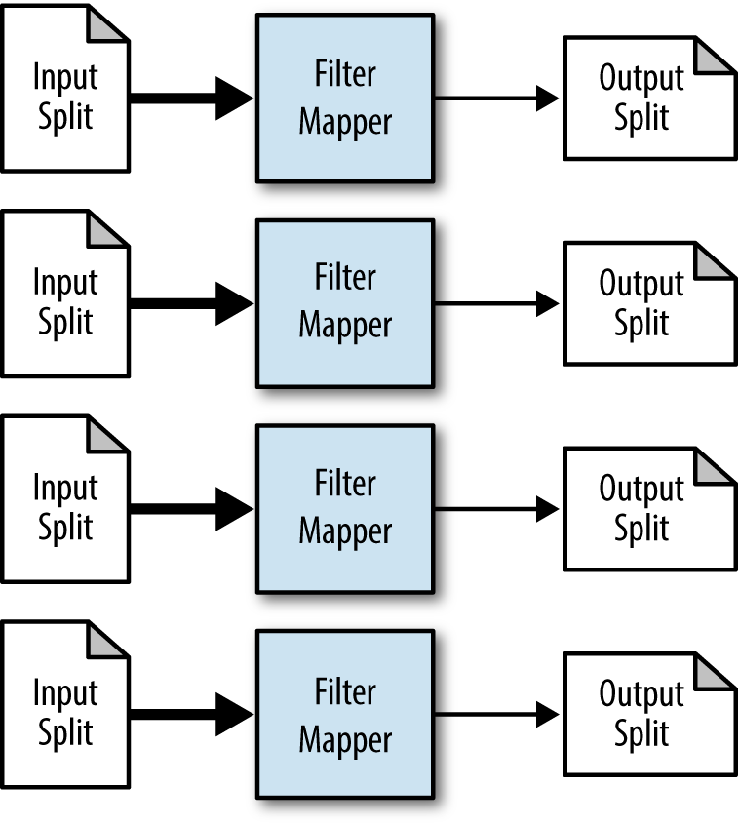

Example: Data Cleaning, random sampling, bloom filtering etc

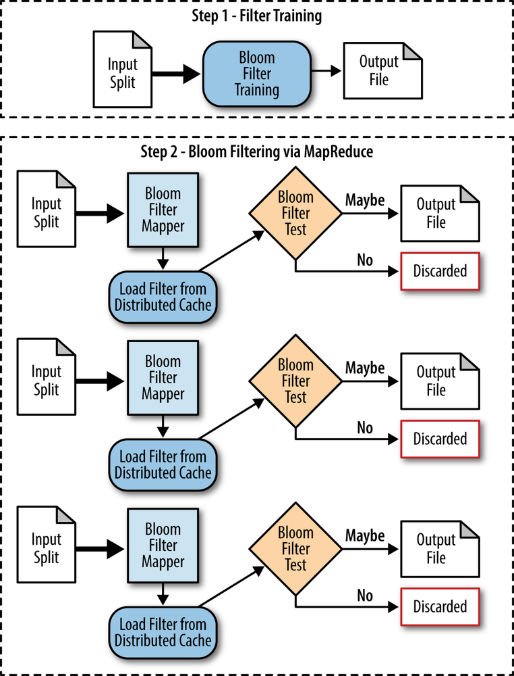

3. Join Patterns

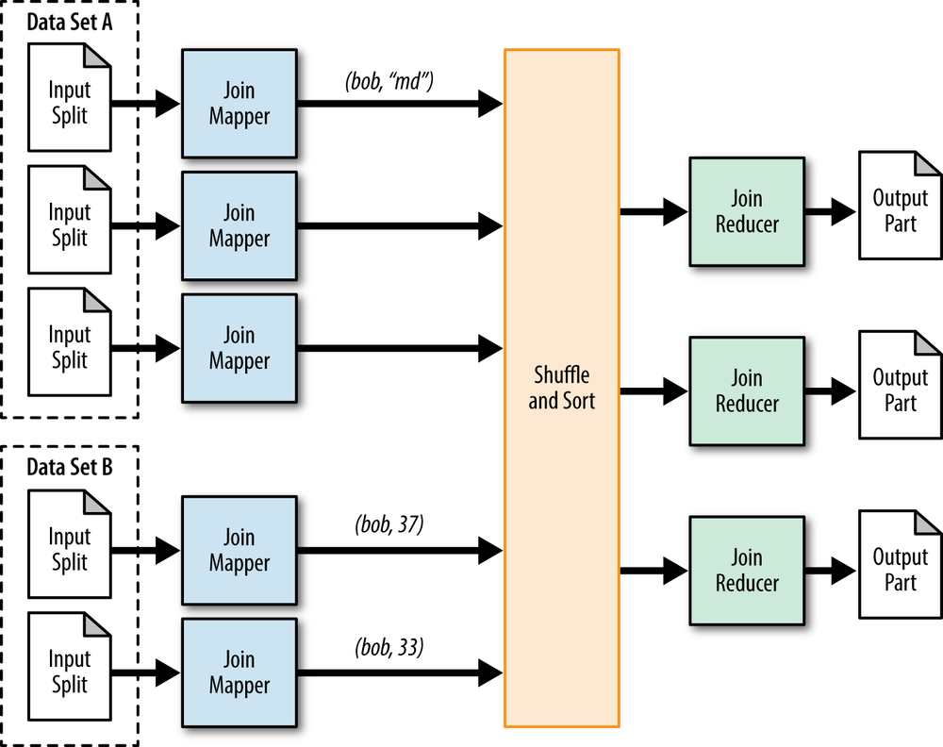

4. Meta Patterns
4.1 Job chaining
Example reuse the output of map reduce step 1 in step 2 and so on till we get the desired output.

What is Map Reduce then?

MapReduce is a programming model that simultaneously processes and analyzes huge data sets logically into separate clusters.

Map is a function which "transforms" items in some kind of list to another kind of item and put them back in the same kind of list.

Reduce is a function which "collects" the items in lists and perform some computation on all of them, thus reducing them to a single value.

While Map sorts the data, Reduce segregates it into logical clusters, thus removing the bad data and retaining the necessary information.

Simple way to understand MR via Analogy

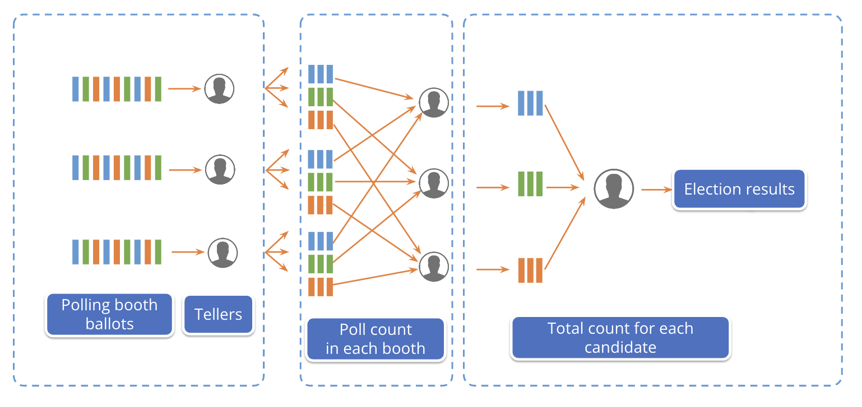
Suppose there is an election going on in the country and for the same, people have casted their votes to respected parties. Now it's the result time so counting of votes are underway.

Each Teller(person who is responsible for counting votes) has been handed over the ballot boxes. So what will the process followed by them:

- Segregate each party vote based on color/symbol. We call this the map phase.
- Now after segregation , it's time to split the votes among tellers. For ex teller A will take responsibility for counting party A votes , same with B and C.
- After this, when each teller gets all votes of a single party , counting will begin and results from each teller will be shared. (Reducer Phase)
- Party with the most votes is declared as the WINNER!!!!

Note : From a to d , everything is happening in parallel.

On the same analogy, Map Reduce works. Divide and Conquer.

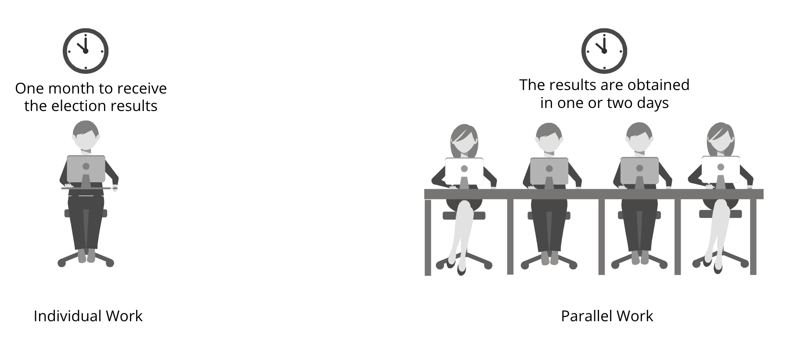

How Does Map reduce work?

To understand MR, we need to know about its phases. A typical MR job has 5 major phases:

- Map Phase
- Partition Phase
- Shuffle Phase
- Sort Phase
- Reduce Phase

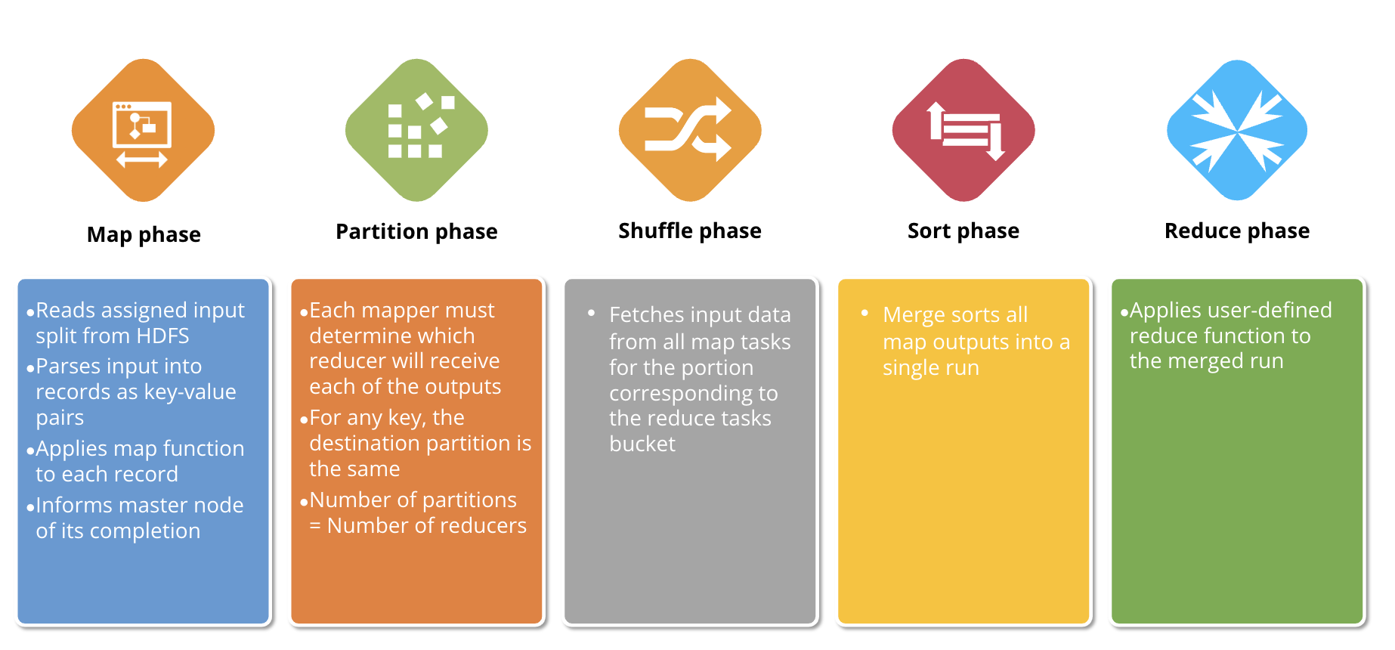

How Did execution take place here ?

Once we create Mapper and Reducer file code, then we pass them to Map Reduce Framework and execution starts in below order :

Note: All below steps are internal to MapReduce Framework and they are actual a java file.

Step 1 : InputFormat →

- FileInputFormat indicates the path of input files and where the output files should be written.
- InputFormat creates the Inputsplit and divides it into records, FileInputFormat, by default, breaks a file into 128MB chunks which is default for HDFS.

Step 2 : InputSplit →

- It represents the data to be processed by an individual Mapper.
- Typically InputSplit presents a byte-oriented view of the input.
- The important thing to notice is that Inputsplit does not contain the input data; it is just a reference to the data.
- As a user, we don’t need to deal with InputSplit directly, because they are created by an InputFormat.
Step 3: RecordReader →

- Typically the RecordReader converts the byte-oriented view of the input, provided by the InputSplit, and presents a record-oriented view to the Mapper implementations for processing.
- RecordReader thus assumes the responsibility of processing record boundaries and presents the tasks with keys and values.
- RR is responsible for creating key value pairs through byte oriented split, by default key will become rowNumber and value will be complete content of Row.
- As in flipkart example, input file will read by RR as 1 being row number as key and rest content as value that will be passed to mapper:

(Key,value )(1, 64.242.88.10 - - [01/Jun/2017:16:05:49 -0800] "GET /twiki/bin/edit/Main/Double_bounce_sender?topicparent=Main.ConfigurationVariables HTTP/1.1" 401 12846)
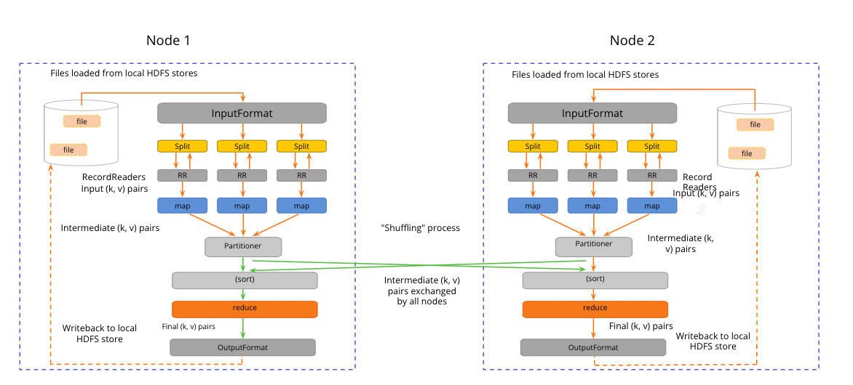

Step 4: Mapper →

- RR output will serve as input to Map Reduce.
- Mapper is a function or task which is used to process all input records from a file and generate the output which works as input for Reducer.
- It produces the intermediate key-value as output by returning new key-value pairs.
- Mapper is a simple user-defined program that performs some operations on input-splits as per it is designed.
- Finally, the intermediate key-value pair output will be stored on the local disk as intermediate output. There is no need to store the data on HDFS as it is an intermediate output.

Mapper Code :

#!/usr/bin/env python
# package: com.hadoop.logger
import java.io.IOException
import java.text.ParseException
import java.text.SimpleDateFormat
import java.util.Calendar
import java.util.Date
import java.util.regex.Matcher
import java.util.regex.Pattern
import org.apache.hadoop.io.IntWritable
import org.apache.hadoop.io.LongWritable
import org.apache.hadoop.io.Text
import org.apache.hadoop.mapreduce.Mapper
class LogMapper(Mapper, LongWritable, Text, IntWritable, IntWritable):
""" generated source for class LogMapper """
hour = IntWritable()
one = IntWritable(1)
logPattern = Pattern.compile("([^ ]*) ([^ ]*) ([^ ]*) \\[([^]]*)\\]" + " \"([^\"]*)\"" + " ([^ ]*) ([^ ]*).*")
sdf = SimpleDateFormat("dd/MMM/yyyy:HH:mm:ss")
def map(self, key, value, context):
""" generated source for method map """
date = None
line = (Text(value)).__str__()
matcher = self.logPattern.matcher(line)
if matcher.matches():
try:
date = Date(sdf.parse(timestamp))
except ParseException as ex:
ex.printStackTrace()
cal.setTime(date)
self.hour.set(cal.get(Calendar.HOUR_OF_DAY))
context.write(self.hour, self.one)

How Many Maps?
The number of maps is usually driven by the total size of the inputs, that is, the total number of blocks of the input files.
The right level of parallelism for maps seems to be around 10-100 maps per-node, although it has been set up to 300 maps for very cpu-light map tasks.

Step 5: Partitioner →
- Partitioner controls the partitioning of the keys of the intermediate map-outputs.
- For example if map output is <1,10> , <1,15> , <1,20> , <2, 13> , <2,6> , <4,8> , <4,20> etc.
  - we can see that there are 3 different keys which are 1, 2 and 4.
  - In map-reduce, the number of reduced tasks are fixed and each reduced task should handle all the data related to one key.
  - That means map output like <1,10>, <1,15>, <1,20> should be handled by the same reduced tasks.
  - It is not possible that <1,10> is handled by one reduce task and <1,15> is handled by another reduce task as the key which is 1 is the same.
- Partitioning is to club the data which should go to the same reducer based on keys.
- HashPartitioner is the default Partitioner.
  - hash(key) % number_of_reducers.
For Instructor : Can explain the same thing with examples from Flipkart too.

Step 6: Shuffling & Sorting →
- In the final output of the map task there can be multiple partitions and these partitions should go to different reduced tasks.
- Shuffling is basically transferring map output partitions to the corresponding reduce tasks

Step 7: Reducer →
- Hadoop Reducer takes a set of an intermediate key-value pair produced by the mapper as the input and runs a Reducer function on each of them.
- One can aggregate, filter, and combine this data (key, value) in a number of ways for a wide range of processing.
- Reducer first processes the intermediate values for a particular key generated by the map function and then generates the output (zero or more key-value pair).
- One-one mapping takes place between keys and reducers. Reducers run in parallel since they are independent of one another.
- The user can decide the number of reducers. By default the number of reducers is 1.
Reducer Code:

ttps://github.com/scaleracademy/dsml-de/tree/main/hadoop/Map-Reduce-Flipkart-Issueh

Job File Code:

https://github.com/scaleracademy/dsml-de/tree/main/hadoop/Map-Reduce-Flipkart-Issue

How Many Reduces?
The right number of reduces seems to be 0.95 or 1.75 multiplied by (<no. of nodes> * <no. of maximum containers per node>).
What if we have Reducer NONE ?
It is legal to set the number of reduce-tasks to zero if no reduction is desired. Reducer NONE means only mapper will do the job and no aggregation is required.

Step 8 : OutputFormat →
Hadoop RecordWriter takes output data from Reducer and writes this data to output files.
The way these output key-value pairs are written in output files by RecordWriter is determined by the Output Format.
The Output Format and InputFormat functions are alike. OutputFormat instances provided by Hadoop are used to write to files on the HDFS or local disk.
OutputFormat describes the output-specification for a Map-Reduce job. On the basis of output specification;
- MapReduce job checks that the output directory does not already exist.
- OutputFormat provides the RecordWriter implementation to be used to write the output files of the job. Output files are stored in a FileSystem.
What are the Steps for building a map Reduce Program?
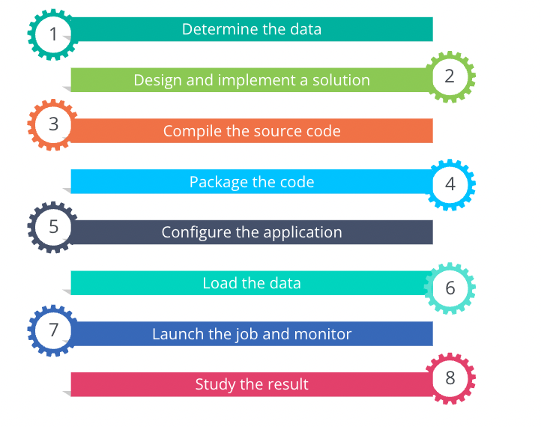
- Determine the data:
  - Identify the data and its format that needs to be processed. In our case we have a log file(apache-log.log).
  - Determine if the data can be made parallel and solved using Map Reduce. For ex : you need to analyze whether the data is WORM(Write Once Read Many) in nature.
- Design and Implementation a solution :
  - Once we have identified the relevant data , now build your own logic by writing 3 files:
    - Mapper File → Strictly write only and only segregation logic
    - Reducer File → Only write custom Aggregation logic like count,sum,
    - Job Config File → To let map reduce framework know which is our custom mapper and custom reducer code , with few more imp config needs to be written here.
- Compile and Package the code:
  - Once all files are created, compile the source code with hadoop core and package the code
- Configure the Application:
  - Configure the job as to the number of mappers and reducer tasks and to the number of input and output streams.
  - We can set it through dynamically while executing our mapper or reducer files or can keep it in the config file.
- Load the data:
  - Finally load the data in HDFS via command and copy the path handy.
- Launch the job and Monitor:
  - Start the job as:
>>>> $HADOOP_HOME/bin/hadoop jar
$HADOOP_HOME/mapred/contrib/streaming/hadoop-streaming*.jar \
-files mapper.py,reducer.py \
-mapper mapper.py \
-reducer reducer.py \
-input /user/hduser/apache-log.log -output /user/hduser/output

Where
Mapper.py,reducer.py → these are our logic
/user/hduser/input.txt → from previous step, location of file which we need for execution.

/user/hduser/output → HDFS file location where we want to see our output file

How to optimize the Map Reduce job ?
Plain vanilla MR code is good for the initial level of job but when one gets into industry , expectations are quite high and focus is on how to write more conducive MR jobs.

Below are recommended optimization strategies:

- Usage of Distributed Cache :
  - Hadoop’s MapReduce framework provides the facility to cache small to moderate read-only files such as text files, zip files, jar files etc. and broadcast them to all the Datanodes(worker-nodes) where the MapReduce job is running.
  - Each Datanode gets a copy of the file(local-copy) which is sent through Distributed Cache. When the job is finished these files are deleted from the DataNodes.

- Take help from Combiners :
  - An optional class that is used at map reduce side to perform local aggregation of the intermediate outputs, which helps to cut down the amount of data transferred from the Mapper to the Reducer.
  - Same code for reducer can be used to specify combiner.
  - Sample code will be :
Job.setCombinerClass(ReducerClass.py)
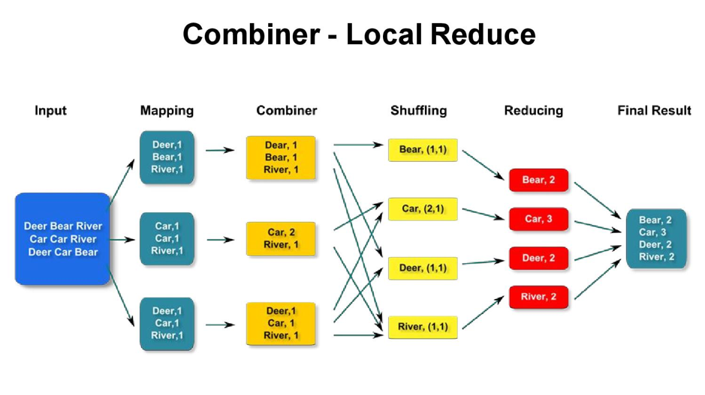
- Do some Memory tuning :
- In Hadoop MapReduce performance tuning the most basic and common rule for memory tuning is: using as much memory as possible without triggering swapping.
- The role memory parameter is mapred.child.java.opts which can be inserted into your config file.

- Tuning of Mappers/Reducers :
  - Hadoop breaks the file into smaller chunks when dealing with large datasets, so that the mapper can run it in parallel.
  - Nevertheless, initializing a new mapper job usually takes a few seconds to minimize which is also an overhead.
  - The suggestions for the same are as follows: Reuse jvm task Target to map tasks that run 1–3 minutes each.
  - For this, if the average running time of the mapper is less than one minute, increase the mapred.min.split.size, assign less mappers in the slot, thus reducing the initializing overhead mapper.

